Fairfield County Recycling

*Recycling 101*

What is Recycling? Recycling is placing items that can be made into new products or materials in the recycling bin or taking them to a drop-off center. But, there's a little more to it than that.

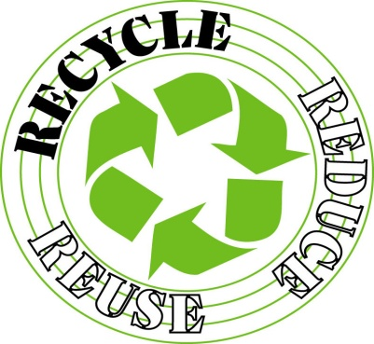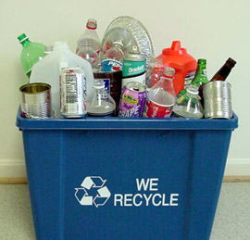

Recycling is a three-step process.

1) The first step is collection — that's when you put your recyclables into the bin or take them to a drop-off center.

2) The second step is manufacturing when the recyclables are processed into raw materials that are then manufactured into new products.

3) The third step is buying recycled. You are not really recycling unless you are buying recycled-content products.

You have seen the recycling symbol, right? The three arrows represent steps that complete the recycling loop.

